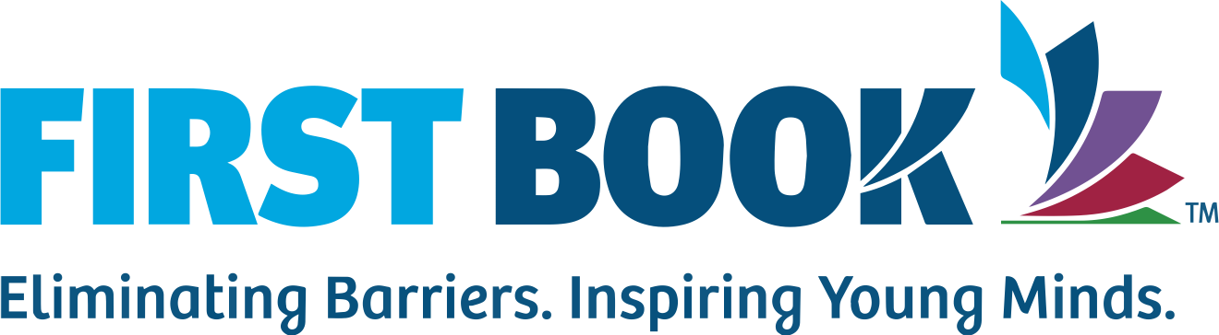
First Book 1319 F St NW
Suite 1000
Washington DC 20004

March 9, 2025

Olivia Yeakel
3081 Muirfield rd.
Center Valley, PA 18034

Dear Olivia,

In honor of National Reading Month this March, our mission to ensure that all children have equitable access to education and books continues to impact low-income communities across North America. Our most recent efforts show that 11.6 million children were served within 2022 to 2023. This number will continue to grow if we receive the support needed from people like you.

The Pennsylvania Department of Education reports that 71% of fourth graders in Philadelphia are not reading at grade level. The literacy crisis is just one of the challenges First Book is working to address. No child deserves to be behind due to lack of support or resources. That’s why we offer First Book Marketplace, an online bookstore providing free resources, school supplies, and affordable books for educators and children. Another option is our Book Bank that allows First Book members the opportunity to order books for just the cost of shipping and processing.

To continue providing these services, we rely on a community of people who care about these issues just as much as we do. A donation to First Book directly impacts a child eager to experience the joy of reading. You can contribute at firstbook.org or use the enclosed donation envelope to make an impact today.
Sincerely,
Kyle Zimmer
Kyle Zimmer
President, founder and CEO

Reflection:
For my first opening sentence, the idea of using National Reading Month came from Read Across America that was a week prior. I also wanted to establish credibility by stating First Book’s mission right off the bat. The following sentence refers to their most recent and impressive statistic which I use to impact the reader. I then refer to the reader by encouraging their support to continue the growth.
I conducted research on the literacy crisis in Philly and found a touching statistic to start off the paragraph. I follow up the statistic with how First Book is trying to help and adding some pathos. I then introduce First Book Marketplace and Book Bank, providing First Book’s resources.
The last paragraph adds more pathos by relying on the community for help. I then ask for a donation, adding more pathos to the statement for an emotional appeal. I conclude with the information needed for donating.

